RESOLUTION NO.__________

RE: CERTIFICATE OF APPROPRIATENESS UNDER THE
PROVISIONS OF THE ACT OF THE PENNSYLVANIA
LEGISLATURE 1961, JUNE 13, P.L. 282 (53
SECTION 8004) AND BETHLEHEM ORDINANCE NO.
3952 AS AMENDED.

WHEREAS, it is proposed replace aluminum widows with stationary and single-hung windows at 822 E. Fourth St.

NOW, THEREFORE, BE IT RESOLVED by the Council of the City of Bethlehem that a Certificate of Appropriateness is hereby granted for the work.

Sponsored by: (s)

(s)

ADOPTED BY COUNCIL THIS DAY OF

(s)
President of Council

ATTEST:

(s)
City Clerk

HISTORIC CONSERVATION COMMISSION

CASE # 622– It is proposed to replace aluminum widows with stationary and single-hung fiberglass windows at 822 E. Fourth St.
OWNER/APPLICANT: First Hispanic Baptist Church/ Janet Perez-Cardona

The Commission upon motion by Ms. Starbuck seconded by Mr. Cornish adopted the proposal that City Council issue a Certificate of Appropriateness for the proposed work described herein:

- The proposal to replace aluminum widows with stationary and single-hung fiberglass windows at 822 E. Fourth St. was represented by Ismael Medina and Lorna Rodriguez-Medina.

- The large classroom windows will be replaced with either:
Option 1: Traco aluminum windows with applied muntins (NX 5400 or equivalent)
Option 2: Pella fiberglass with muntin GBG. The applicant must work with the Historic Officer on the muntin placement and proportions.

- The window frames may be covered with break metal capping. The color of the metal capping will be brown to approximately match windows on the 2nd floor windows.

- Smaller windows without transoms will be 2 mulled single-hung units.

- The windows to be replaced will be on the third floor and one on the stair landing.

- The motion to approve the proposal was unanimously approved.

CU: cu
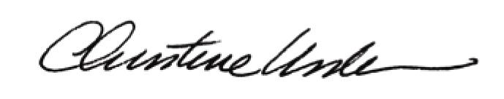

By:

Date of Meeting: August 21, 2017 Title: Historic Officer

